A
PROJECT REPORT
ON
"Library Management System"
Developed for
Women's College of Home Science And BCA, Loni
Submitted to
Savitribai Phule Pune University, Pune
Submitted by
Miss. PORNIMA ANJALI SHARAD MORE .
Miss. SONAL JYOTI SANDIP TIDAKE .
Under The Guidance Of
Dr. Tambe R. R.
For The Academic Year
2026-2027
In Partial Fulfilment of the Course
B.Sc.(Computer Applications)
DEPARTMENT OF THE COMPUTER APPLICATIONS

Loknete Dr. Balasaheb Vikhe Patil (Padma Bhushan Awardee)
Pravara Rural Education Society's
Women's College of Home Science and BCA, Loni
Tal- Rahata, Dist- Ahilyanagar, Pin-413713


A
PROJECT REPORT
ON
"Library Management System”
Submitted to
Savitribai Phule Pune University, Pune
Submitted by
Miss. PORNIMA ANJALI SHARAD MORE .
Miss. SONAL JYOTI SANDIP TIDAKE
Under The Guidance of
Dr. Tambe R. R.
For the academic year
2026-2027
In Partial Fulfilment of the Requirement for the Award of Degree
B.Sc. (Computer Applications)
Loknete Dr. Balasaheb Vikhe Patil (Padma Bhushan Awardee)
Pravara Rural Education Society's
Women's College of Home Science and BCA, Loni
Tal-Rahata, Dist- Ahilyanagar, Pin-413713

PROJECT SUBMISSION

Submitted by

Miss. PORNIMA ANJALI SHARAD MORE .
Miss. SONAL JYOTI SANDIP TIDAKE

The Student of Third Year
B.Sc. (Computer Applications)
Humbly submit the Project

"LIBRARY MANAGEMENT SYSTEM"

I have completed the project work on time to time according to project infrastructure predefined by Savitribai Phule Pune University, Pune by my own skill under the guidance of internal project guide and the faculty members of College.

Student Signature Student Signature
Miss. Sonal Tidake Miss. Pornima More

Loknete Dr. Balasaheb Vikhe Patil (Padma Bhushan Awardee)

Pravara Rural Education Society's

Women's College of Home Science and BCA, Loni

Tal. Rahata, Dist. Ahmednagar, 413713

CERTIFICATE

This is to certify that project developed by
Miss. PORNIMA ANJALI SHARAD MORE .
Miss. SONAL JYOTI SANDIP TIDAKE .

The Students of Third Year BCA Has successfully completed their software project
On

"LIBRARY MANAGEMENT SYSTEM"
In the partial fulfilment for the award for
B.Sc. (Computer Applications)
As per the Course Curriculum of Savitribai Phule Pune University
During the Academic Year 2026-2027

Dr. Wani S.T. External Examiner
H.O.D

Dr. Tambe R. R. Dr. Anushree Khaire
Project Guide I/C Principal
DECLARATION

The software project titled “Library Management System” has been meticulously planned, developed, and executed by us as part of the partial fulfilment of our academic requirements for the Third Year BCA program, in accordance with the curriculum prescribed by Savitribai Phule Pune University, Pune.
This project has been undertaken under the guidance and supervision of our esteemed project guide and faculty members, who provided us with invaluable instructions, insights, and support throughout the development process. All aspects of this project, including analysis, design, coding, and testing, have been carried out independently by us.
It is important to acknowledge that the successful completion of this project was made possible due to the comprehensive teaching, guidance, and mentorship provided by our faculty. This project is hereby submitted to Savitribai Phule Pune University, Pune, as part of the requirements for the BCA course. Developed, learned, and completed at Loknete Women’s College of Home Science and BCA, Loni.

ACKNOWLEDGEMENT

I extend our heartfelt gratitude to Savitribai Phule Pune University, Pune, for providing us with the platform to undertake and complete this project.
I express our deepest appreciation to our esteemed Project Guide, Dr. Tambe R. R., whose valuable guidance and insightful advice have been instrumental in steering us through the challenges of this project. Her encouragement and motivation have been pivotal in our journey toward success. I would also like to extend our sincere thanks for her constant encouragement and support throughout the project's development phase. Her valuable inputs and suggestions have greatly contributed to the refinement and finalization of this project.
I would also like to thank Dr. Anushree Khaire, HOD of BCA department, Dr. Wani S. T., and other faculty members Dr. Jadhav S. M., Assit. Prof. Ghogare A. S., Assit. Prof. More S. M., Assit. Prof. Gondhali K. L., and Assit. Prof. Vikhe R. S. for their guidance and cooperation, which have helped me navigate through various aspects of this project.
Furthermore, I are truly grateful to my friends and family, whose moral support and encouragement have strengthened my determination and efficiency.
Lastly, I sincerely appreciate everyone who has supported and motivated me throughout this journey. Their belief in my abilities has been a source of inspiration, and I are truly thankful for their contributions to my learning and growth.

With sincere thanks,
Miss. PORNIMA ANJALI SHARAD MORE .
Miss. SONAL JYOTI SANDIP TIDAKE

INDEX

Sr.No | Title
1. | Introduction of project  - Introduction  - Project Overview  - Objectives  - Hardware and Software requirement  - Frontend and Backend  - Need of the system  - Scope of the system
2. | System Analysis  - Fact-Finding Techniques  - Feasibility Study
3. | System Diagrams  - Entity Relationship (E-R ) Diagram  - Data Flow Diagram (Level 0 & Level 1)
4. | Database Design  - Data Dictionary (Table Structures)
5. | User Interface
6. | System Evaluation  - Advantages  - Limitations
7. | Future Enhancement
8. | Cost Of Project
9. | Conclusion
10. | Bibliography

INTRODUCTION

A Library Management System is a software application designed to simplify and organize the daily operations of a library. It serves as a centralized platform where books and digital resources can be catalogued, tracked, and accessed efficiently. By integrating features such as student registration, book issue and return, and search functionality, it ensures that both librarians and users can manage resources with ease.
Automating library tasks is important because it eliminates the inefficiencies of manual record keeping, reduces errors, and saves valuable time. With automation, searching for books becomes faster, issuing and returning items is more accurate, and maintaining transparency in borrowing history is effortless. Moreover, such systems can scale to handle large collections and multiple users simultaneously, making libraries more accessible and user-friendly. Ultimately, automation enhances the overall experience for students, researchers, and staff, while modernizing the way libraries function.

PROJECT OVERVIEW

A Library Management System (LMS) is a software application designed to manage and automate the daily operations of a library. It helps in organizing books, managing member records, tracking issued and returned books, and maintaining overall library efficiency. The system replaces traditional manual methods with a digital platform, reducing paperwork and minimizing errors. It provides an easy way to store, retrieve, and update information related to books, users, and transactions.
The main objective of the Library Management System is to simplify library activities such as book issuing, returning, searching, and inventory management. It enhances user experience by allowing quick access to information and ensures proper record maintenance.
Key users of the system include:
Librarian – manages books, members, and transactions
Students/Staff – search books and check availability
The system typically includes features like:
Book management (add, update, delete records)
Member management
Issue and return tracking
Search functionality
Overall, the Library Management System improves efficiency, saves time, and ensures accurate record-keeping, making it an essential tool for modern libraries.

OBJECTIVES

1. Books/Resources:
• To manage all books, journals, magazines, and other resources in the library.
2. Members/Users:
• To store and manage information about library members, including students, staff, and others.
3. Borrowing Records:
• To track which members have borrowed which books and their return status.
4. Fines/Payments:
• To manage overdue fines or payments for lost or damaged resources.
5. Reports:
• To generate reports on library usage, book availability, overdue items, and more.
6. Librarian/Admin:
• To provide control over library operations, including adding or removing books, managing user accounts, and monitoring system usage.
who are always on the go, our systems come with remote access features, which will allow you to manage your workforce anytime, at all times.
Application includes:
- Login Form
- Admin Page
- Student Information
- Book Information

Hardware and Software Requirement

Hardware Requirement:
- Memory Storage: 238 GB
- Processor: 12th Gen Intel(R) Core(TM) i5-1235U (1.30 GHz)
- RAM: 16 GB
Software Requirement:
Front End:
- HTML
- CSS
- JavaScript
Back End:
- MySQL (Database)

Front-End

HTML (Hypertexts Markup Language):
HTML is the foundational markup language used to create the structure of web pages. In the Library Management system, HTML is used to design pages such as the login form, registration page, account dashboard, and transaction pages. It provides the layout for content, forms, tables, and links, allowing the system to display information clearly to the user. Without HTML, the web interface would not have any structure for users to interact with.
CSS (Cascading Style Sheets):
CSS is used to style and format HTML elements, making the web pages visually appealing and easy to use. In the online Library system, CSS controls colors, fonts, spacing, page layouts, and responsive design to ensure the system works well on different devices. It separates the design from the content, providing a consistent and professional look for all pages such as dashboards, forms, and menus.
JavaScript:
JavaScript is a programming language used to make web pages interactive and dynamic. In the Library Management system, JavaScript handles client-side validations, such as checking login credentials before submitting forms, displaying alerts, and updating content in real-time without reloading pages. It enhances user experience by making the system responsive, interactive, and user-friendly.

Back-End

MySQL:

MySQL is a relational database management system used to store and manage data for the web application. In the online library system, it stores user information, account details, and transaction history. MySQL enables secure, organized, and efficient data storage, retrieval, and manipulation. MySQL is used as the backend database for the Library Management System. It stores and manages all the important information related to the library, such as student details, book details, issue and return records, and administrator information. MySQL helps the system to efficiently add, update, delete, and retrieve data whenever required.

Need Of The System

Efficient Resource Management:
Manual record-keeping is time-consuming and prone to errors. A digital system ensures accurate cataloging, quick retrieval, and systematic organization of books and resources.
Time-Saving Operations:
Automated processes such as book issue/return, fine calculation, and membership management reduce workload and save valuable time for both staff and students.
Easy Accessibility:
Users can search for books, check availability, and reserve resources online, eliminating the need to physically visit the library for basic queries.
Data Security and Reliability:
Digital systems provide secure storage of records, minimizing the risk of data loss or misplacement compared to manual registers.
User Convenience:
Students and faculty can access the system anytime, anywhere, making it more user-friendly and aligned with modern academic needs.
Scalability and Future Growth:
As institutions grow, the system can easily accommodate more users, resources, and advanced features without disrupting existing workflows.

Scope Of The System

1. Book Management
- Add, update, and delete book records.
- Maintain details like title, author, publisher, and quantity.
- Track availability of books.
2. Member Management
- Register new users (students, staff).
- Maintain member details.
- Update or remove user records.
3. Issue and Return System
- Issue books to members.
- Record return of books.
- Track due dates and overdue books.
4. Search Functionality
- Search books by title, author, or category.
- Check real-time availability of books.
5. Report Generation
- Generate reports for issued books, returned books, and overdue records.
- Maintain history of transactions.
6. User Roles
- Admin/Librarian: Full control over system operations.
- Users/Students: Limited access (search and view books).
- Administrators can maintain and update system data when required.

SYSTEM
ANALYSIS

Fact Finding Techniques

Fact-finding techniques are structured methods used in system analysis and business analysis to gather accurate requirements and understand user needs.
The most common techniques include interviews, questionnaires, observation, document analysis, sampling, prototyping, and Joint Requirements Planning (JRP).
- Interviews
- Talk with librarians, staff, and students.
- Example: Ask librarians about challenges in tracking overdue books, or students about difficulties finding titles.
- Surveys
- Distribute questionnaires to members and staff.
- Focus Groups
- Organize small group discussions with students and staff.
- Observation
- Watch how staff issue/return books and how students search catalogs.
- Document Analysis
- Review existing records: membership forms, book issue registers, fine receipts, and catalog databases.

Feasibility Study

The only tangible benefit provided by the proposed system is that the paperwork is reduced to the minimum and hence the reduction in cost incurred on stationery and its storage. The system provides many benefits that can't be measured in terms of money, for example, user's friendliness, more user response being more efficient
TECHNICAL FEASIBILITY STUDY :-
The proposed system is technically feasible as it can be developed easily with the available technology. The proposed system requires HTML, CSS & back-end as MySQL for storing/maintaining database. The database can be easily interconnected using MySQL Connect.
ECONOMICAL FEASIBILITY STUDY :-
Economic analysis is most frequently used for evaluation of the effectiveness of the system. More commonly known as cost/benefit analysis, the procedure is to determine the benefit and saving that are expected from a system and compare them with costs, decisions is made to design and implement the system. This part of feasibility study gives the top management the economic justification for the new system. A simple economic analysis that gives the actual comparison of costs and benefits is much more meaningful in such cases. It is economically feasible, it will only require a single operator to operate the system.
OPERATIONAL FEASIBILITY STUDY :-
Automation makes our life easy. The proposed system is highly user friendly and is much easily able to interact with the system. Therefore, the users will readily accept the system as data entry and making queries can be easily done.

SYSTEM
DIAGRAMS

E-R Diagram for Library Management System

E-R (Entity Relationship) Diagram is used to represents the relationship between entities in a table.

E-R diagram means Entity Relationship Diagram. Entity means object of system, generally we refer entity as database table, the E-R diagram represents the relationship between each table of the database. E-R diagram represent entity with attributes, attributes is a property of entity. If we assume entity is a database table then all the columns of table are treated as attributes.

E-R Diagram Symbols

Symbols | Name of the Symbol
 | Entity
 | Relationship
 | Attribute
 | Weak Entity
 | Weak Relationship
 | Line

E-R Diagram
Author
email
Category
name
status
name
course
ID
Status

Issued by

Manages
Satus
Issue_return date
Book name
ID

ID
Role
Name
Role
Name
ID
Name
ID
Librarian
Issue_Return
Staff
Student
Takes
Books
DFD Diagram Symbols

Symbol | Description
 | Data Flow: Data Flow are pipelines through which packets of information flow.
 | Process: A process or task performed by the system.
 | Entity: Entity are objects of the system. A source or destination of data of a system.
 | Data Store: A data store is a place where data is stored, managed, and accessed for future use.

0 LEVEL DFD

Student
Staff
Library Management System .
Librarian

1 LEVEL DFD

Book transaction Book details

Book Storage System
Book Transaction
System
Request for book
Check availability
& issue book
Student/Staff

Librarian
Staff Registration
System
Registers

Verify staff details

Staff_info

Student Registration System
Registers
Verify student details

Student_info
Data Dictionary

Books Table
Column Name | Data Type | Constraint
id | INT | Primary Key, Auto Increment
book_name | VARCHAR(100) | NOT NULL
author | VARCHAR(100) | NOT NULL
category | VARCHAR(50) | NOT NULL
status | VARCHAR(20) | Default: Available

Students Table
Column Name | Data Type | Constraint
id | INT | Primary Key, Auto Increment
name | VARCHAR(100) | NOT NULL
course | VARCHAR(50) | NOT NULL
email | VARCHAR(100) | NOT NULL
status | VARCHAR(20) | Default: Active

Staff Table
Column Name | Data Type | Constraint
id | INT | Primary Key, Auto Increment
name | VARCHAR(100) | NOT NULL
mobile | VARCHAR(15) | NOT NULL
email | VARCHAR(100) | NOT NULL
role | VARCHAR(100) | NOT NULL
status | VARCHAR(20) | Default: Active

Issued Books Table
Column Name | Data Type | Constraint
id | INT | Primary Key, Auto Increment
student_id | INT | NOT NULL
student_name | VARCHAR(100) | NOT NULL
book_id | INT | NOT NULL
book_name | VARCHAR(100) | NOT NULL
issue_date | DATE | NOT NULL
status | VARCHAR(20) | Default: Issued

Returned Books Table
Column Name | Data Type | Constraint
id | INT | Primary Key, Auto Increment
student_id | INT | NOT NULL
student_name | VARCHAR(100) | NOT NULL
book_id | INT | NOT NULL
book_name | VARCHAR(100) | NOT NULL
return_date | DATE | NOT NULL
status | VARCHAR(20) | Default: Returned

USER INTERFACE

Home Page :
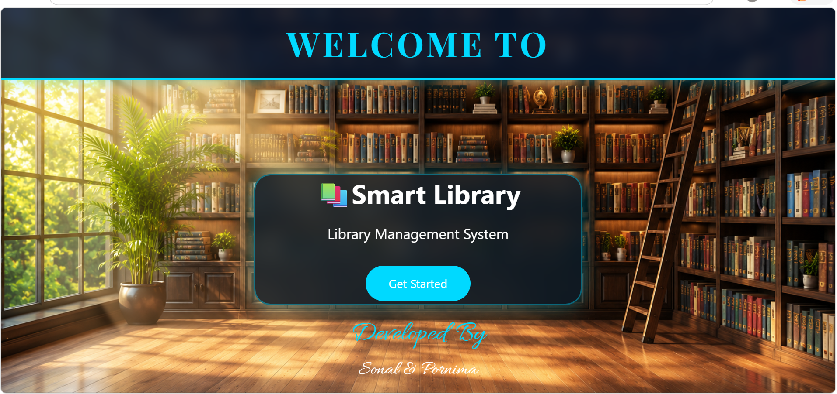
Login Page :
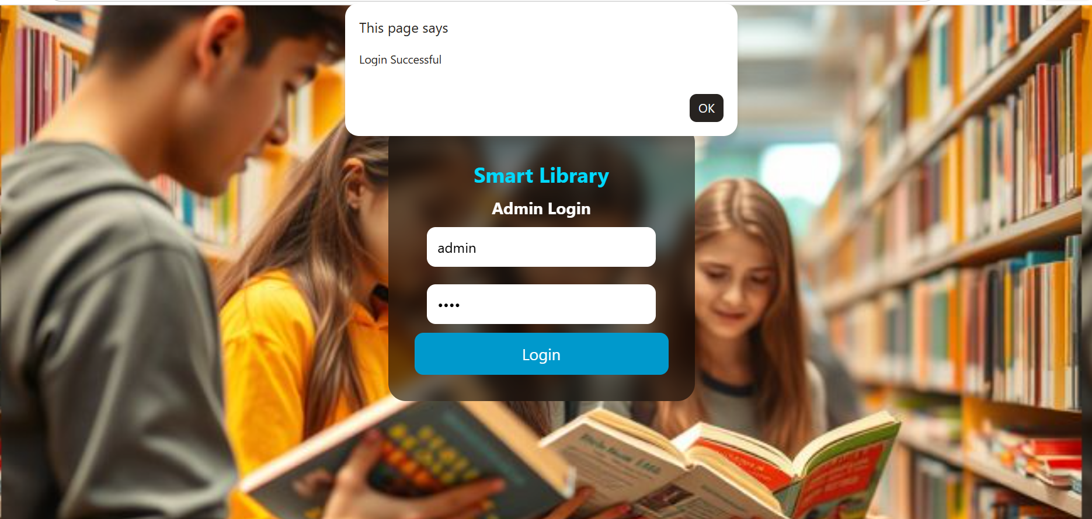

Dashboard :
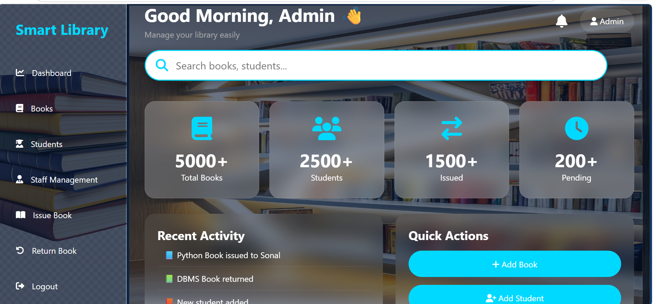

Book Management Page :
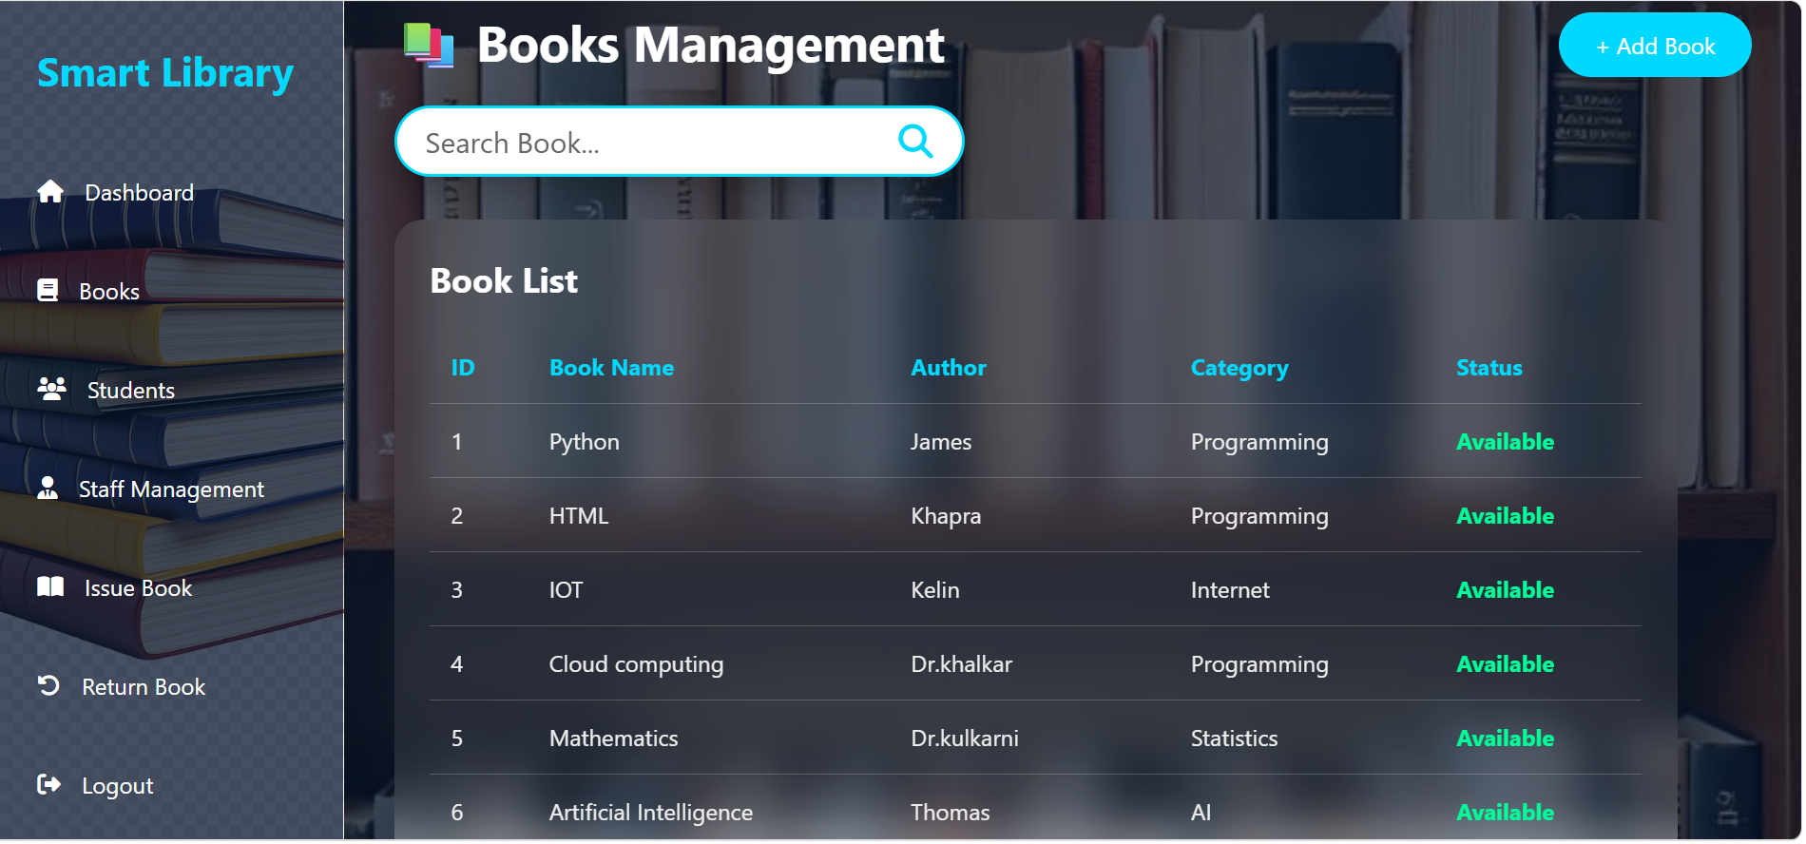
Book Search :
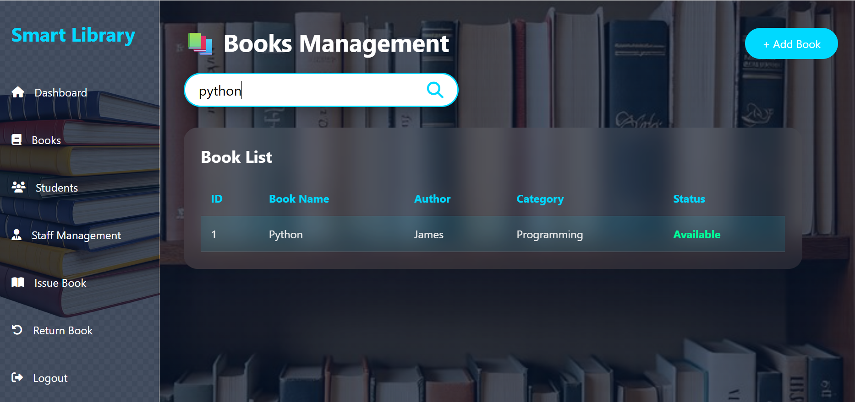

Add New Book :
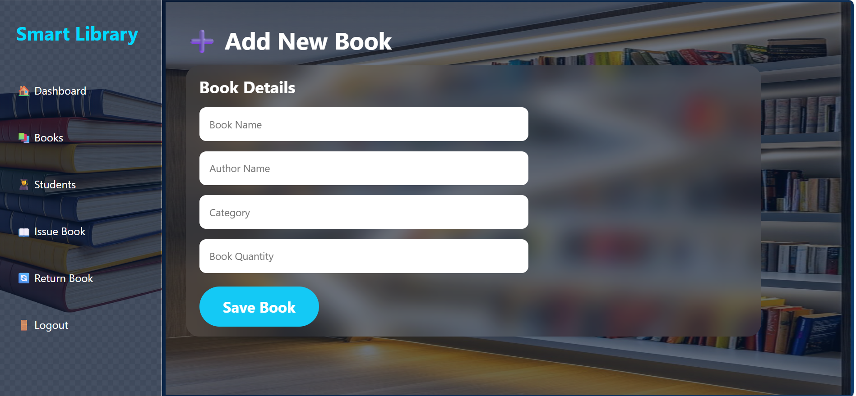
Student Management Page :
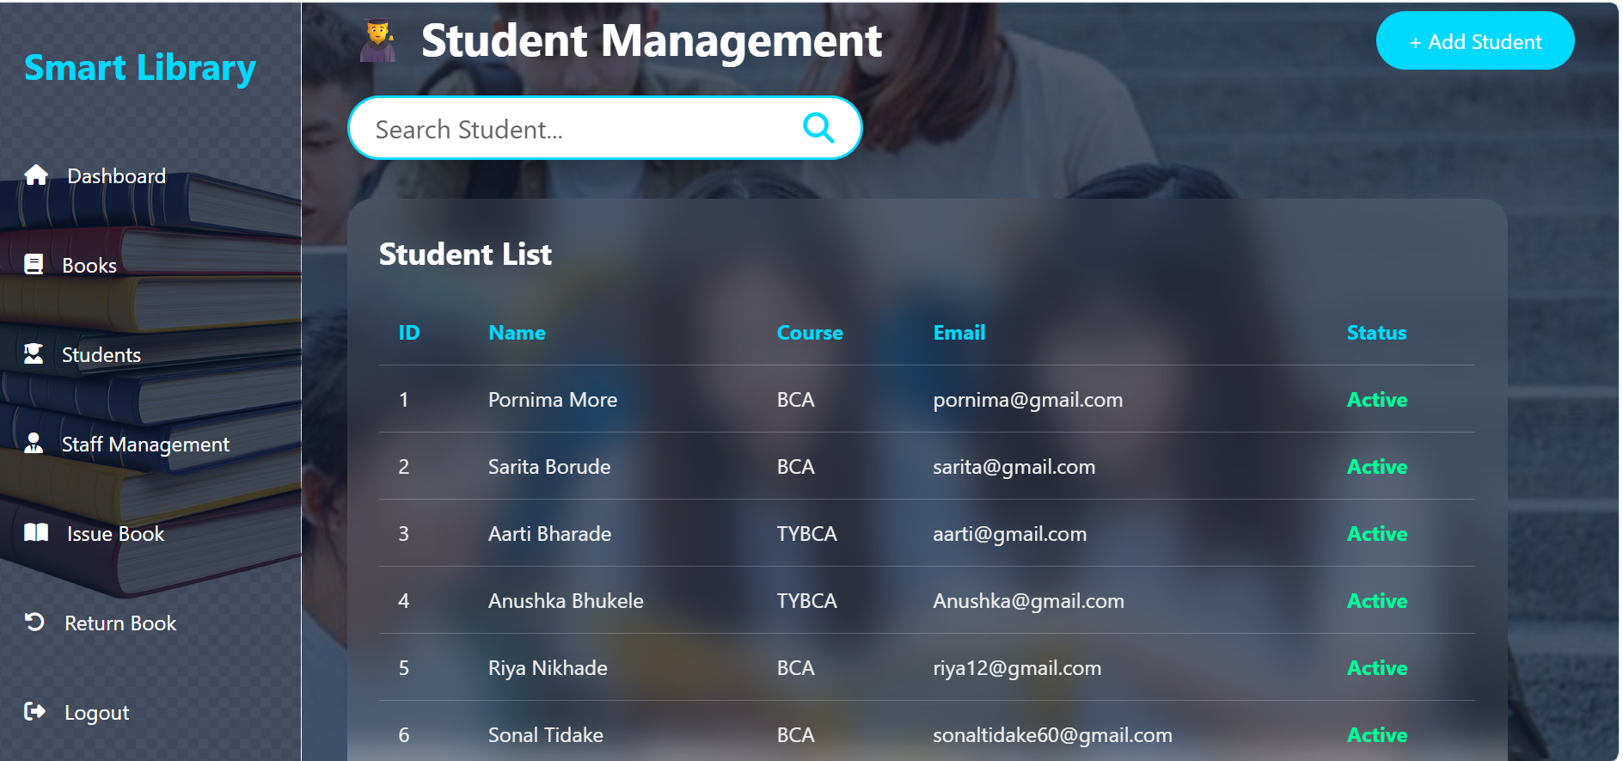

Add Student :
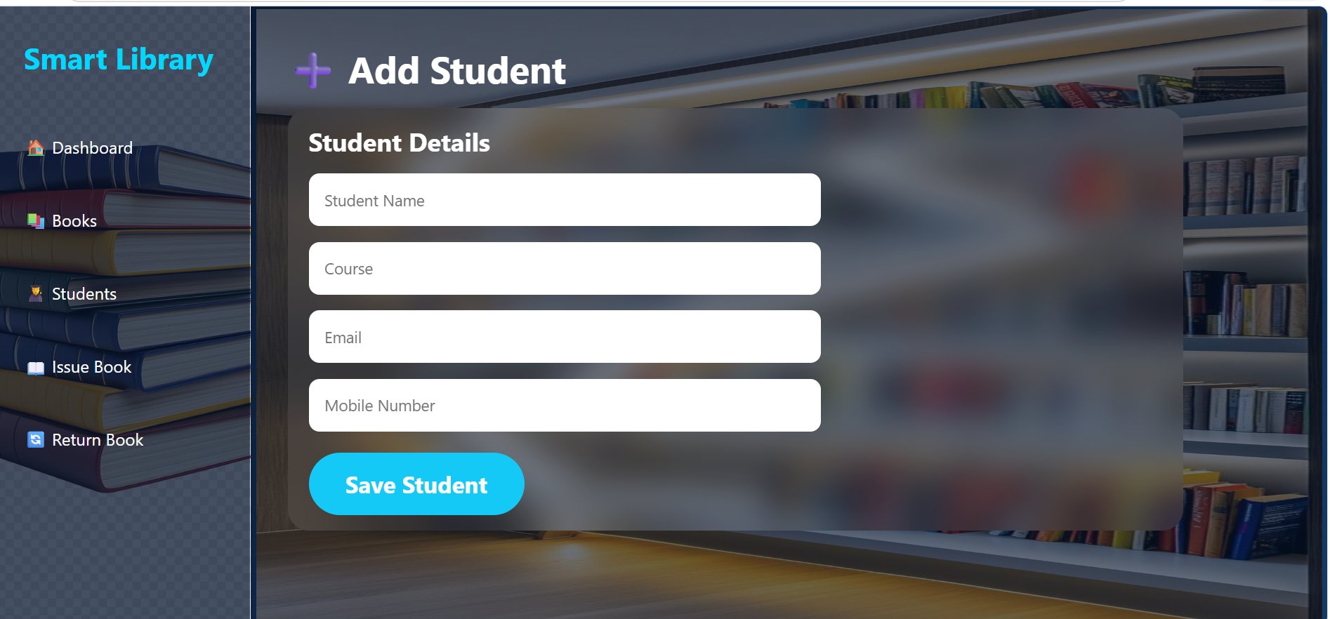
Search Student :
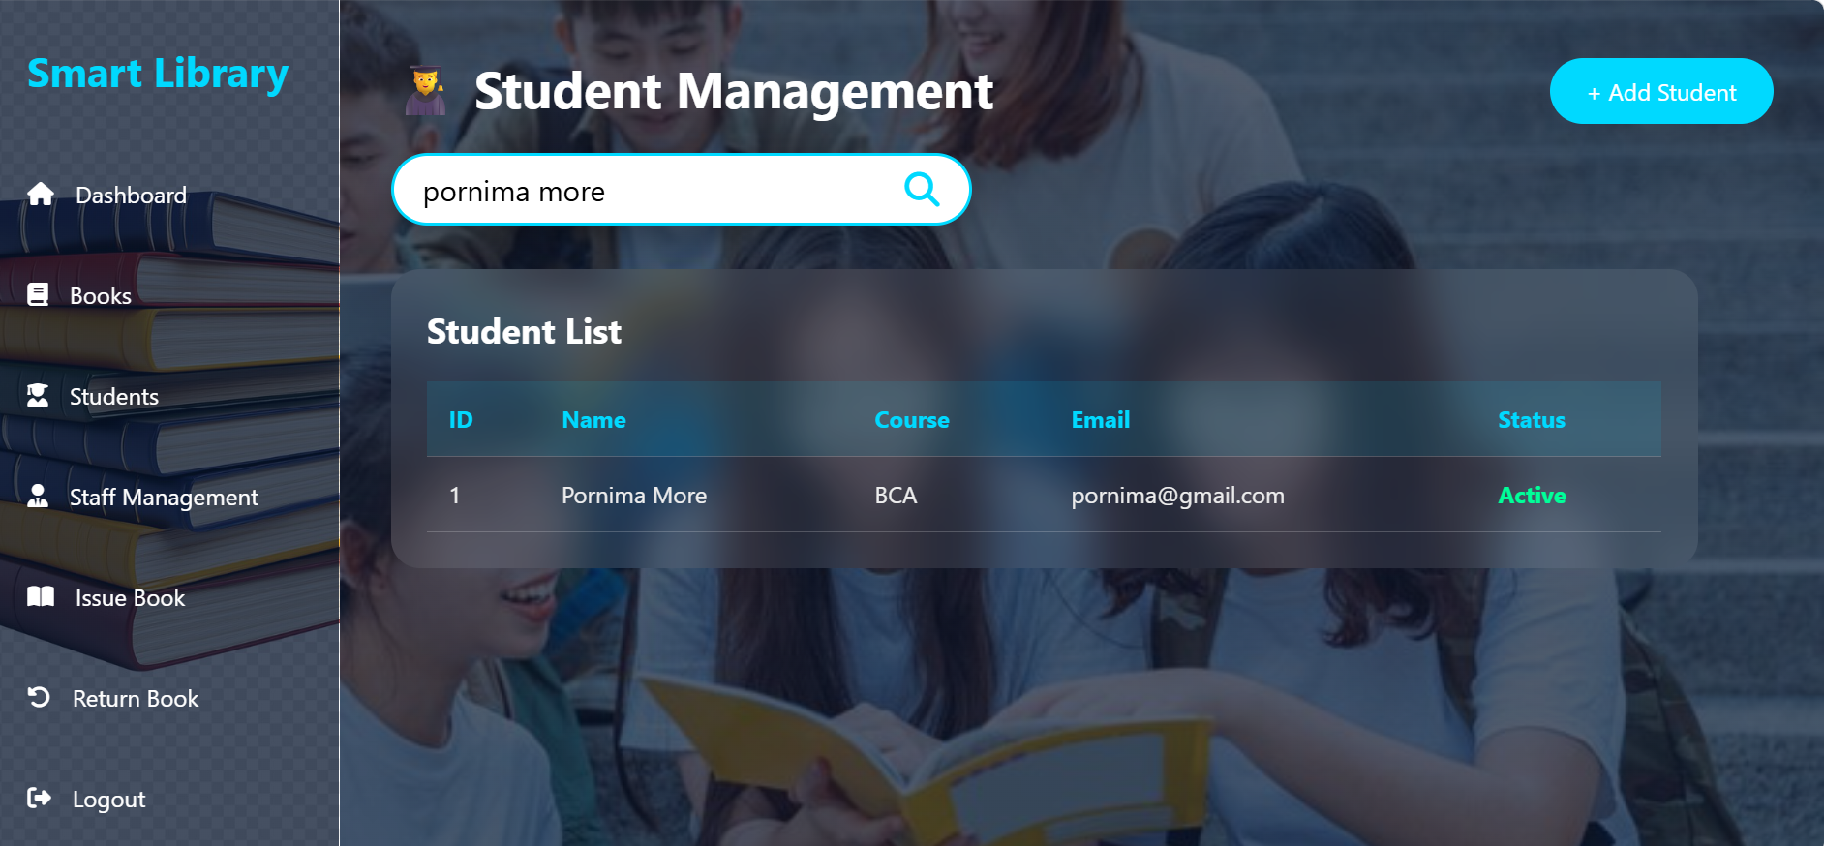

Staff Management :
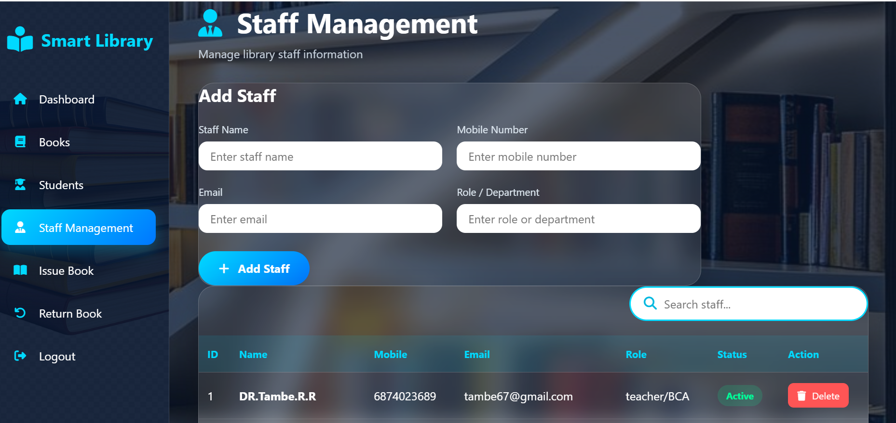

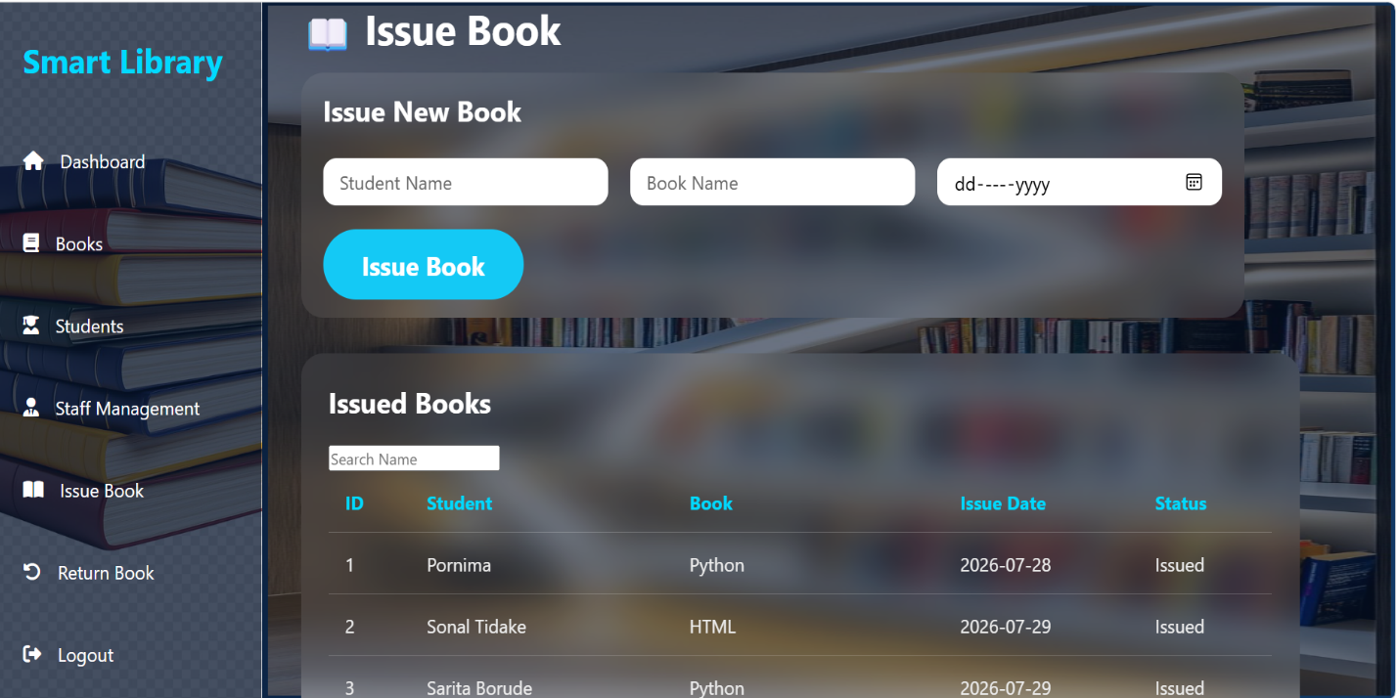
Issue Book Page :

Student Issue Record :
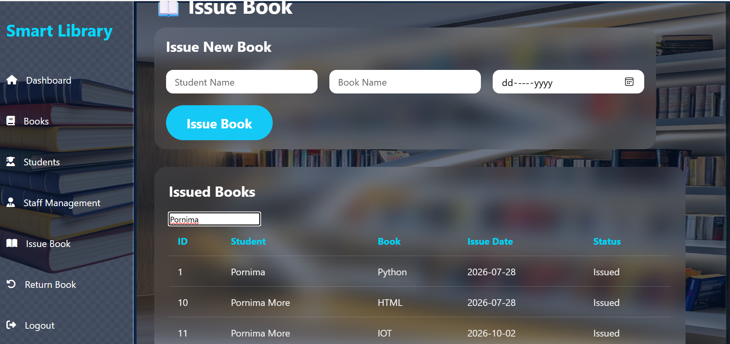
Return Book Page :
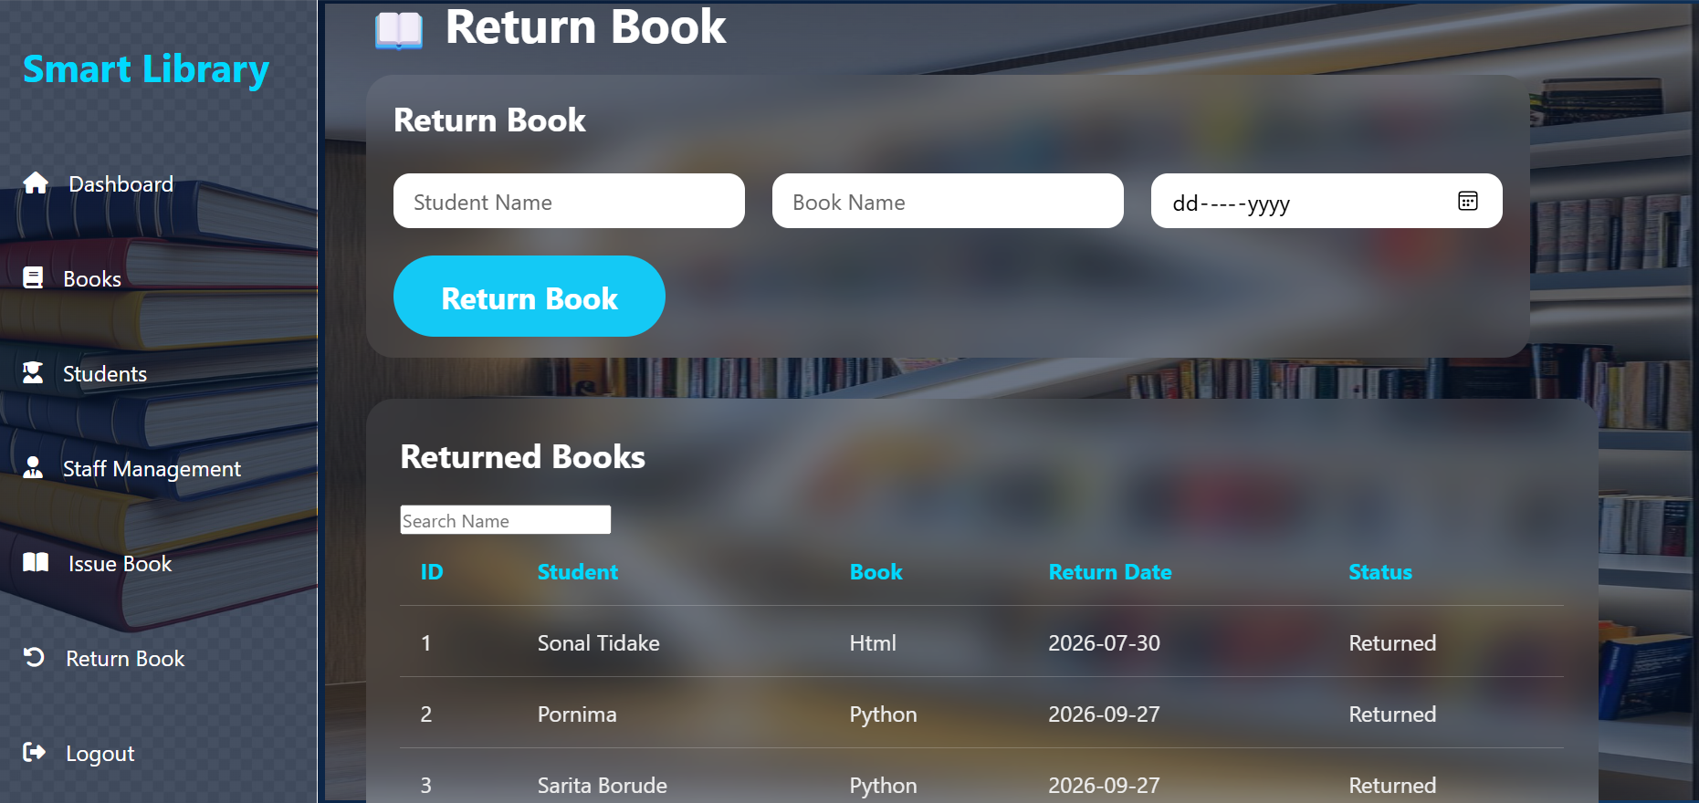

Student Return Record :
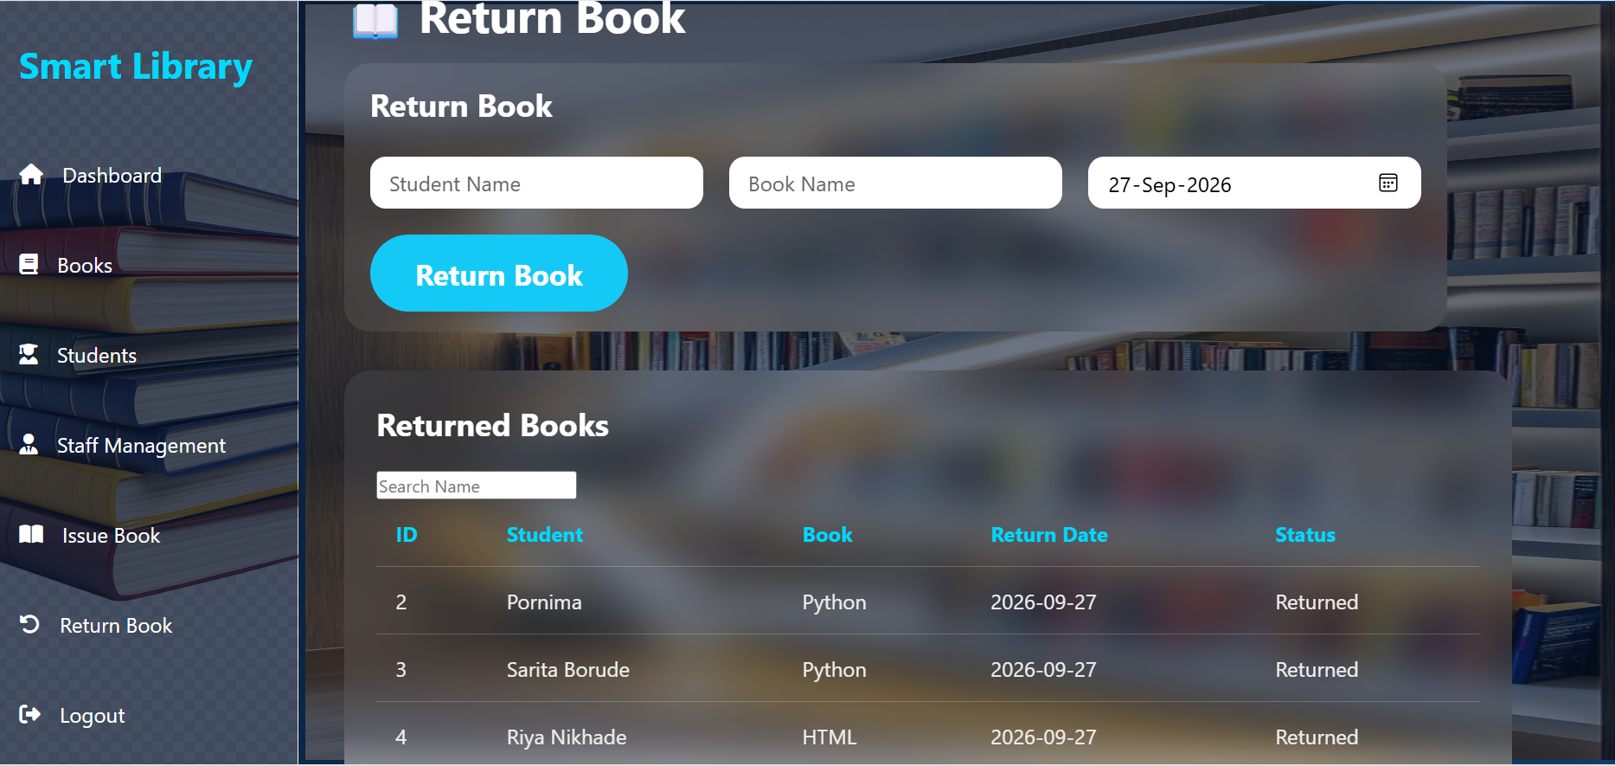
Advantages and Limitations

Advantages:
1. Easy Book Management
- Maintains records of all books in an organized way.
2. Saves Time
- Fast issuing and returning of books.
- Reduces manual work.
3. Quick Search
- Users can easily find books by title, author, or category.
4. Accurate Records
- Minimizes human errors in data entry and calculations.
5. Better Security
- Keeps data safe and prevents loss of records.
6. User-Friendly
- Easy to use for both students and librarians.
7. Report Generation
- Generates reports like issued books, returned books, fines, etc

Limitations

1. Initial Cost
- Setup cost for software and system.
2. Maintenance Required
- Needs regular updates and technical support.
3. Dependency on System
- If the system fails, work may stop.
4. A Risk of Data Loss
- Data can be lost due to system failure or hacking.

Cost of Project

Considering the different factors, we are going to decide the cost of the project Library Management System developed by us.
- Number of Weeks = 15
- Number of Hours per Week = 14
- Number of Partners = 2
- Main Hours = Number of Weeks × Number of Hours per Week × Number of Partners
= 15 × 14 × 2
= 420 hrs.
- Rate per Hour = 20
- Cost = Main Hours × Rate per Hour
= 420 × 20
= 8,400
- Coding and Designing
No. of Source Lines = 800
Rate per Line = 2
Coding Cost = No. of Source Lines × Rate per Line
= 800 × 2
= 1,600
- Total Cost = Cost + Coding Cost
= 8,400 + 1,600
= 10,000

Conclusion

The Library Management System (LMS) serves as a comprehensive solution to modernize and streamline library operations. By integrating secure authentication, role-based dashboards, efficient book management, and automated borrowing/return processes, it ensures smooth functioning for students, staff, and librarians alike.
- Efficiency: Reduces manual work by automating book issue, return, and fine calculation.
- Accuracy: Maintains reliable records with proper validation and secure database operations.
- Accessibility: Provides a user-friendly interface with responsive design for easy access across devices.
- Scalability: Supports future enhancements like analytics, notifications, and digital resources.
In conclusion, the LMS not only enhances the productivity of library staff but also improves the overall user experience for students and readers. It transforms a traditional library into a smart, organized, and secure system that aligns with modern educational needs.

Bibliography

Reference Websites:

https://www.geeksforgeeks.org/

https://www.chatgpt.com/

https://www.youtube.com/

https://www.Google.com

